**Portfolio Milestone Option 2**

Lance I. Evans

Colorado State University Global

CSC580-1: Applying Machine Learning and Neural Networks - Capstone

Dr. Brian Holbert

18 May 2023

The MAE plot shows the Mean Absolute Error (MAE) values over the epochs during the model training. The x-axis represents the number of epochs, and the y-axis represents the MAE. The average error is 2.0265, meaning that on average, the model’s predictions have an absolute difference of 2.0265 from the true MPG values in the test set.

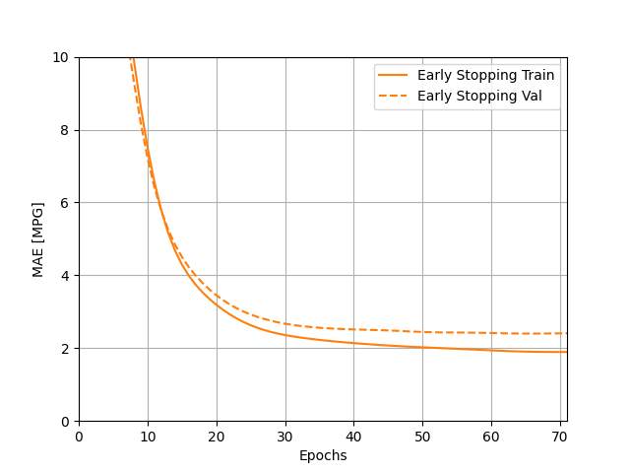

A lower MAE value indicates better accuracy, therefore the model’s predictions are reasonably close to the true MPG values. 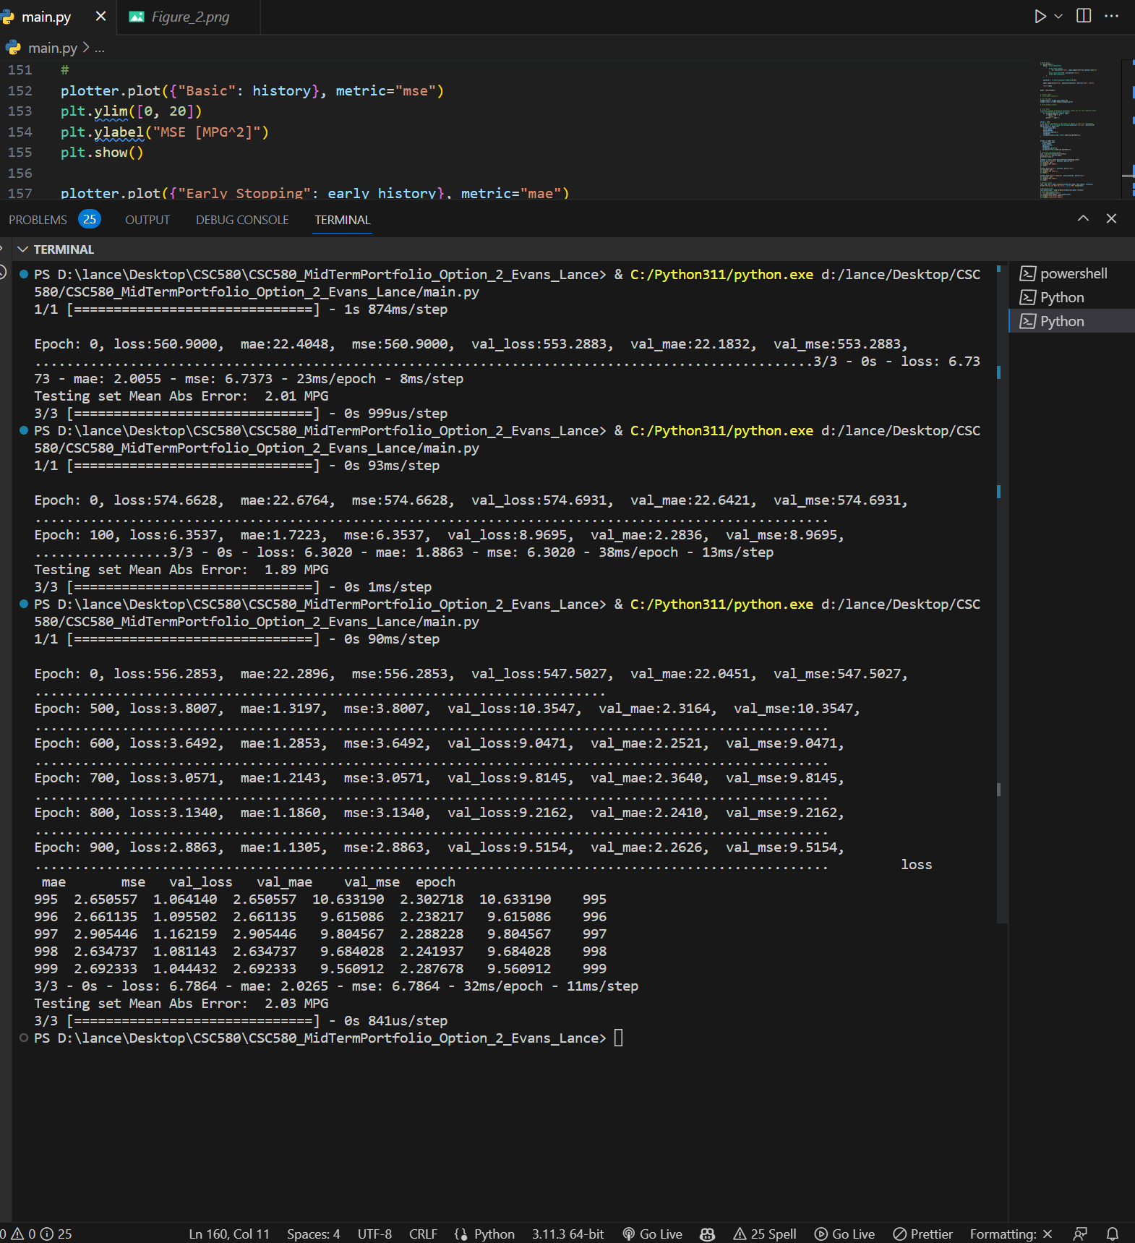

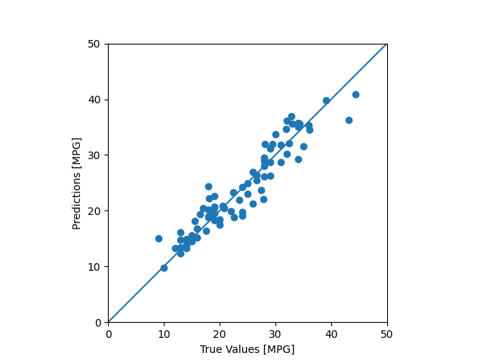

This scatter plot displays the predicted values as well as the actual values for MPG. From the visual alone, we can see that the model performed relatively well. 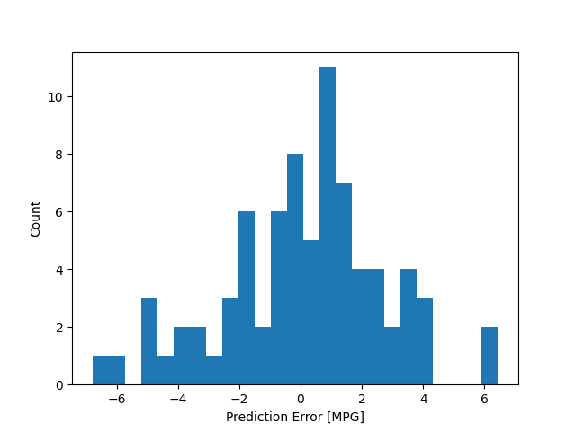

This graph displays the amount of times the model had a prediction error and to what degree it occurred. This shows that for the majority of time throughout the predictions, the model was really close to being correct. Additionally, this graph shows that the model was more likely to overestimate the MPG values rather than underestimating.